# Google Cloud Fundamentals: Getting Started with Compute Engine

## Task 2: Create a virtual machine using the GCP Console

* Comand Line Equivelent

gcloud beta compute --project=qwiklabs-gcp-02-7d318273e6a1 instances create my-vm-1 --zone=us-central1-a --machine-type=e2-medium --subnet=default --network-tier=PREMIUM --maintenance-policy=MIGRATE --service-account=20274609616-compute@developer.gserviceaccount.com --scopes=https://www.googleapis.com/auth/devstorage.read_only,https://www.googleapis.com/auth/logging.write,https://www.googleapis.com/auth/monitoring.write,https://www.googleapis.com/auth/servicecontrol,https://www.googleapis.com/auth/service.management.readonly,https://www.googleapis.com/auth/trace.append --image=debian-9-stretch-v20200902 --image-project=debian-cloud --boot-disk-size=10GB --boot-disk-type=pd-standard --boot-disk-device-name=my-vm-1 --reservation-affinity=any

## Task 3: Create a virtual machine using the gcloud command line

* To display a list of all the zones in the region

Input

student_02_9eedc18d6238@cloudshell:**~ (qwiklabs-gcp-02-7d318273e6a1)**$ gcloud compute zones list | grep us-central1

Output

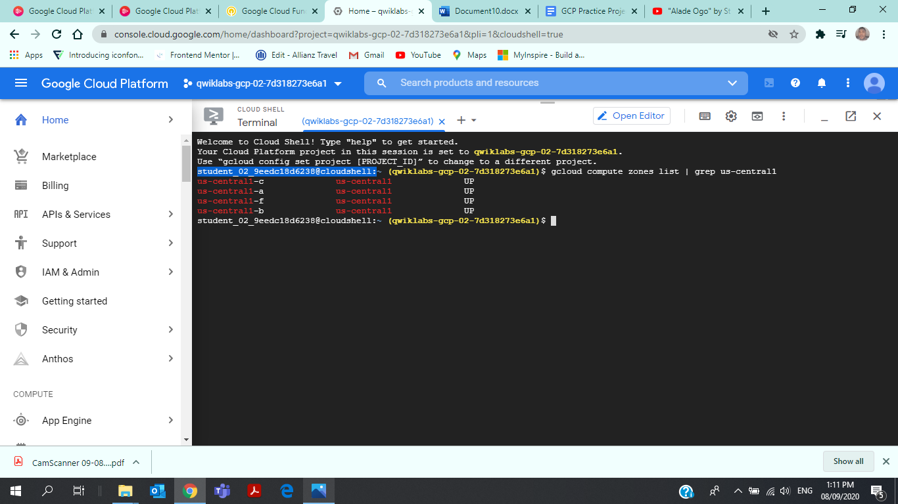

* To set your default zone to the one you just chose

Input

student_02_9eedc18d6238@cloudshell:**~ (qwiklabs-gcp-02-7d318273e6a1)**$ gcloud config set compute/zone us-central1-b

Output

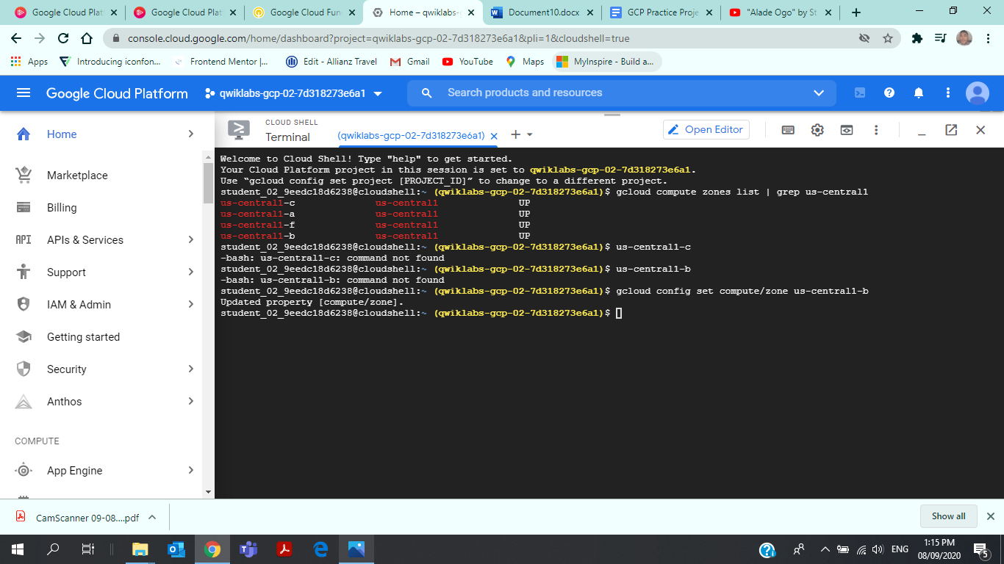

* To create a VM instance called **my-vm-2**

Input

student_02_9eedc18d6238@cloudshell:**~ (qwiklabs-gcp-02-7d318273e6a1)**$ gcloud compute instances create "my-vm-2" \> --machine-type "n1-standard-1" \> --image-project "debian-cloud" \> --image "debian-9-stretch-v20190213" \> --subnet "default"

Output

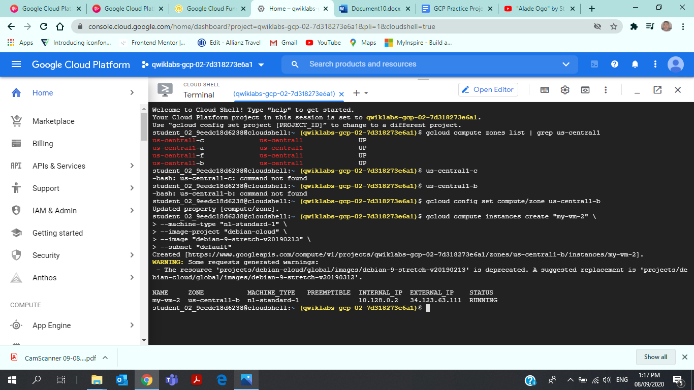

* To close the Cloud Shell

Input

exit

## Task 4: Connect between VM instances

* Use the ping command to confirm that **my-vm-2** can reach **my-vm-1** over the network

Input

**student-02-9eedc18d6238@my-vm-2**:**~**$ ping my-vm-1

Output

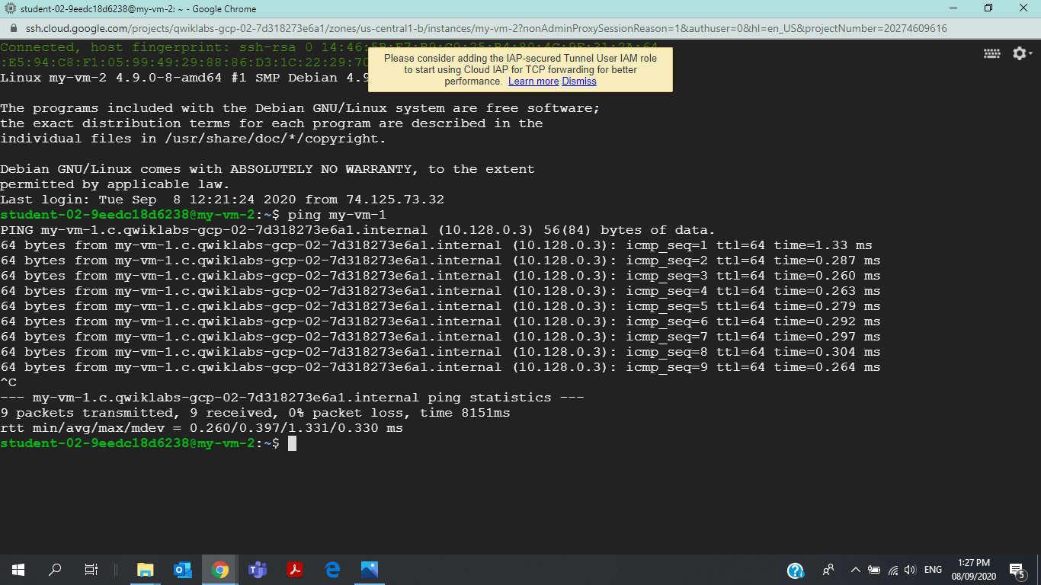

* Use the **ssh** command to open a command prompt on **my-vm-1**

Input

**student-02-9eedc18d6238@my-vm-2**:**~**$ ssh my-vm-1

* At the command prompt on **my-vm-1**, install the Nginx web server

Input

**student-02-9eedc18d6238@my-vm-2**:**~**$ sudo apt-get install nginx-light -y

* Use the **nano** text editor to add a custom message to the home page of the web server

Input

**student-02-9eedc18d6238@my-vm-2**:**~**$ sudo nano /var/www/html/index.nginx-debian.html

* Confirm that the web server is serving your new page

Input

**student-02-9eedc18d6238@my-vm-2**:**~**$ curl http://localhost/

* To exit the command prompt

Input

**exit**